Code Reviewing Check List

1. **Project and File names**

Criteria :Use Pascal Case

* CourseApiController:Ok

1. **Always begin from the top**

Criteria :Remove Using Statements

* CourseApiController:Remove using StudentBL;

1. **Sort all the using statements**

Criteria : New using statement at last

* CourseApiController:Ok

Criteria : Using Statements in Alphabetical order

* CourseApiController:Ok

1. **Don’t just ignore warnings**

Course Api Controller

Got above warning



When fixing this it add mor warning so not fixed -Not OK

1. **Code Consistency**

Same data type display as same way

Eg:int ,Int32

* CourseApiController:Ok

1. **Do care for Null all the times**

Criteria : Check if object get null

CourseApiController

Add Highlighted code to Course Api Controller

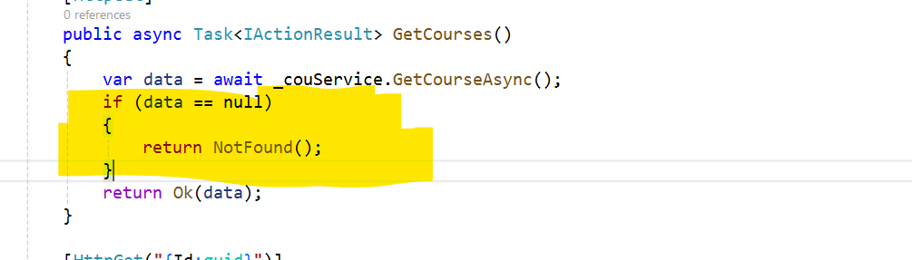

1. **Dead code**

Criteria : Remove all unnecessary code comments

CourseApiController:Ok

1. **Naming Convention**

Criteria: Method name in Pascal Case ,variable ,parameter name in Camel Case

CourseApiController:

* Method Names:Ok
* Variable:Ok
* Parameters:Fixed

1. **Code Readability**

Criteria: single line spacing wherever applicable between the code blocks

CourseApiController:Fixed

1. **Handling Unmanaged Resources**

Criteria: handle unmanage codes like using blocks

CourseApiController :Ok

1. **Write Defensive Code**

Criteria: Explicit Error handling

CourseApiController :Fixed

1. **Declare access specifiers explicitly**

Criteria: Add Access specifier before variables

CourseApiController : Ok

1. **Self Documenting Code**

Criteria:Code describe the what they do